Microsoft Team Multipart Integration (Interview Module)

Application Creation
An application for Zwayam is to be created on client’s Azure Portal.
Steps:
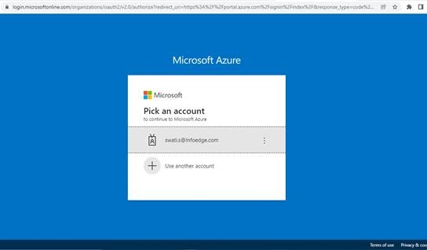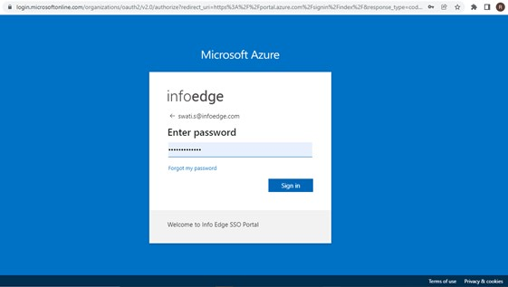
1
. Login
to Azure
portal (
https://portal.azure.co
m
)
.

2. Go to All services 3. Search for App registrations
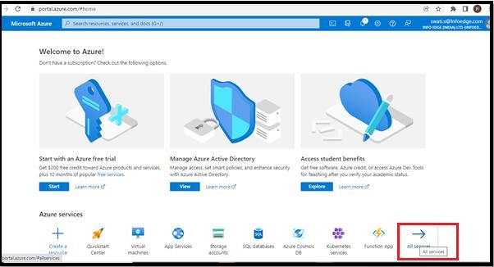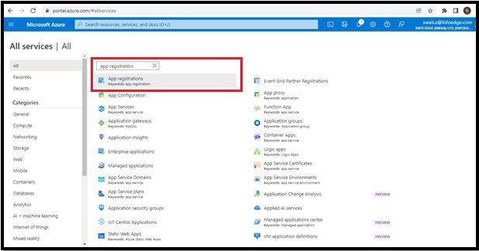

4. Click on New registration 5. In the section ‘Name’, enter ‘Zwayam’
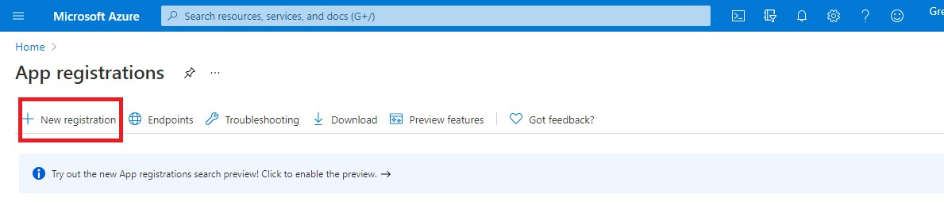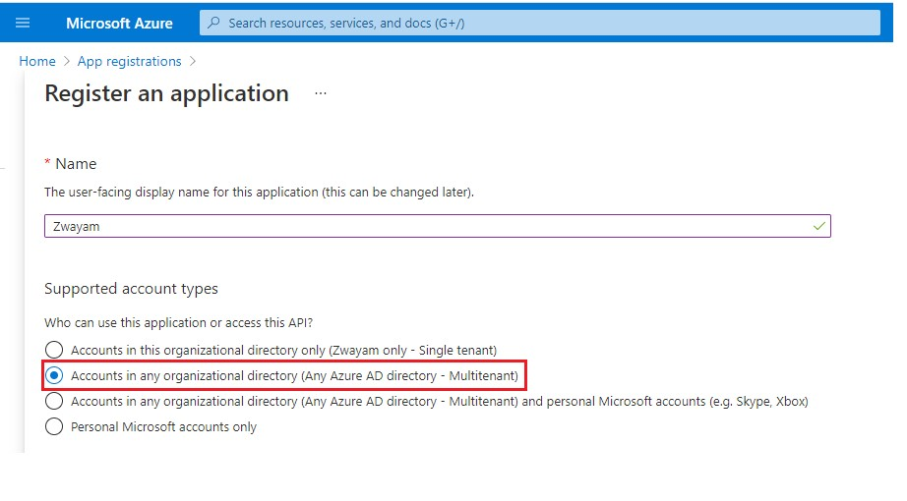
While registering, enable multitenant access for the API.

6. Procure and share the Application (Client) ID & Directory (Tenant) ID which you can find on the Overview tab with Zwayam.

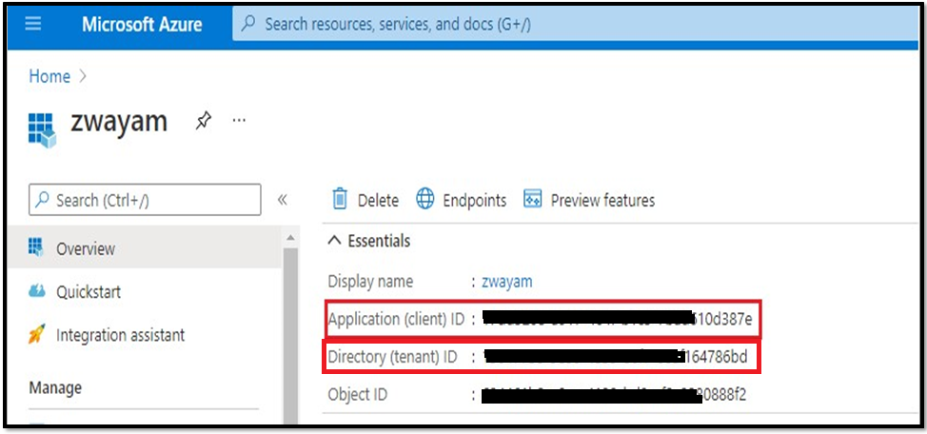

Authentication
Steps:
- Go to Authentication tab from left hand menu. Click on Platform configurations and select Single Page Application.

- Add the below Redirect URLs provided by Zwayam.
https://snapmintcreditadvisoryprivatelimited.impl.openings.co/manage/v1/
https://snapmintcreditadvisoryprivatelimited.openings.co/manage/v1/

- Grant token access. 4. Ensure Multitenant access is given to the API.
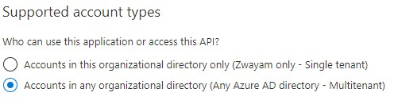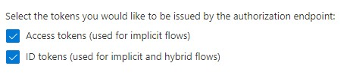

5. Enable public client flows. 6. Finally, click on save after making the changes
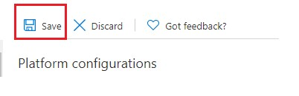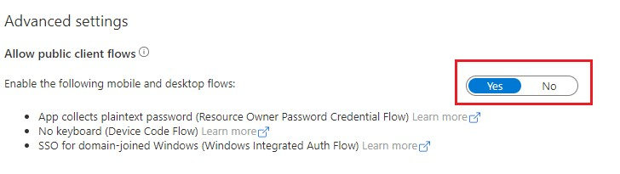

API Permissions
In API permission tab, we have to add the following API permissions –
- Calendars.ReadWrite
- openid
- Profile
- User.ReadBasic.All

Steps:
- Click on Add a permission icon.
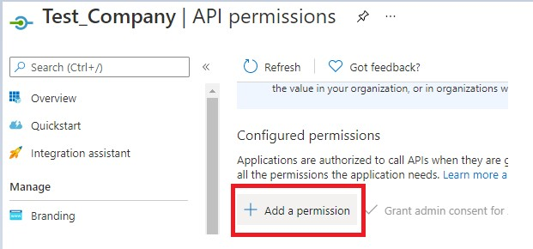

- Select Microsoft Graph as the API.
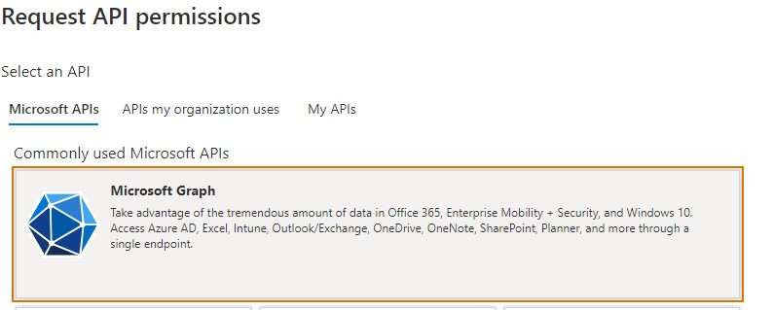

- Under Delegated Permissions, search and select the API permissions to be added.
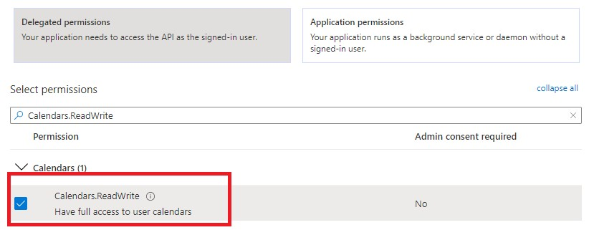

- Click on Add permissions to add the selected APIs.
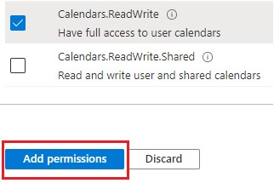

* Repeat steps 3 and 4 for all the required permissions.
- Finally, the admin of the azure portal should grant access to the added APIs.
